Guidelines for annotating molecular carrier activity

# 

# Pathway Editor

The activity unit for a molecular carrier is:

* **MF**: a molecular carrier 'enables' molecular carrier activity ([GO:0140104](https://www.ebi.ac.uk/QuickGO/term/GO:0048018)) or a child
* **Context:** 
  + The relation between a transported molecule and its carrier is *'*has input'. The carrier and the small molecule are linked with the 'has output' relation, so that the small molecule can be the input for the next reaction.
  + **BP** 'part of' the process in the molecule using the small molecule participates, or 'part of' regulation of the process, if the carrier is regulators (rate-limiting for the execution of the process)
  + **CC**: 'occurs in' the cellular location where the activity takes place.

Example 1: [LPS is carried to its receptor by CD14](http://noctua.geneontology.org/workbench/noctua-visual-pathway-editor/?model_id=gomodel%3A5f46c3b700001031)

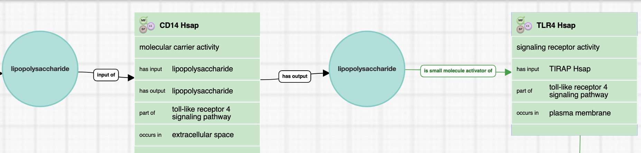

# 

# Form Editor

The activity unit for a molecular carrier is:

* **MF**: a molecular carrier 'enables' molecular carrier activity ([GO:0140104](https://www.ebi.ac.uk/QuickGO/term/GO:0048018)) or a child
* **Context:** 
  + The relation between a transported molecule and its carrier is *'*has input'. The carrier and the small molecule are linked with the 'has output' relation, so that the small molecule can be the input for the next reaction.
  + **BP** 'part of' the process in the molecule using the small molecule participates, or 'part of' regulation of the process, if the carrier is regulators (rate-limiting for the execution of the process)
  + **CC**: 'occurs in' the cellular location where the activity takes place.

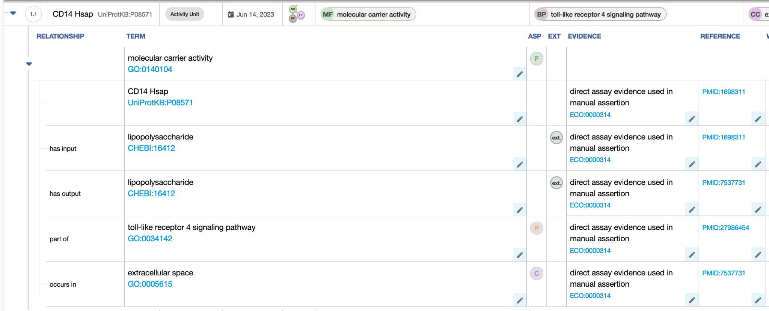

# Differences between GO-CAM and standard annotation for a molecular carrier activity

The same information is captured for the carrier activity and its context; however in the standard annotations,it is not possible to capture the order of the reactions.

# Review information

Review date: 2023-07-25

Reviewed by: Cristina Casals, Pasclae Gaudet, Patrick Masson